

**FLOOD**

**MONITORING**

**USING IOT**



**INTRODUCTION**

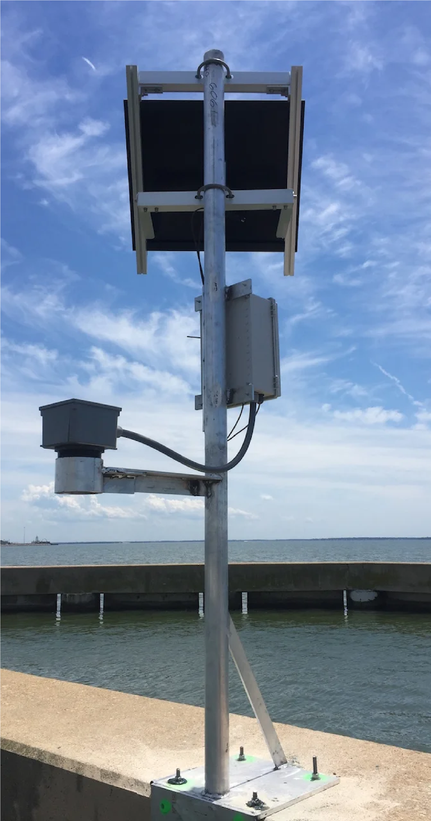

A Flood Monitoring System in the realm of

Internet of Things (IoT) represents a

transformative solution designed to

address the increasing challenges posed

by floods, a natural disaster with

widespread and devastating

consequences.

we have gained the capability to create a

comprehensive and real-time monitoring

system that can continuously collect and

analyze data related to water levels,

weather conditions, and other relevant

parameters in flood-prone areas.

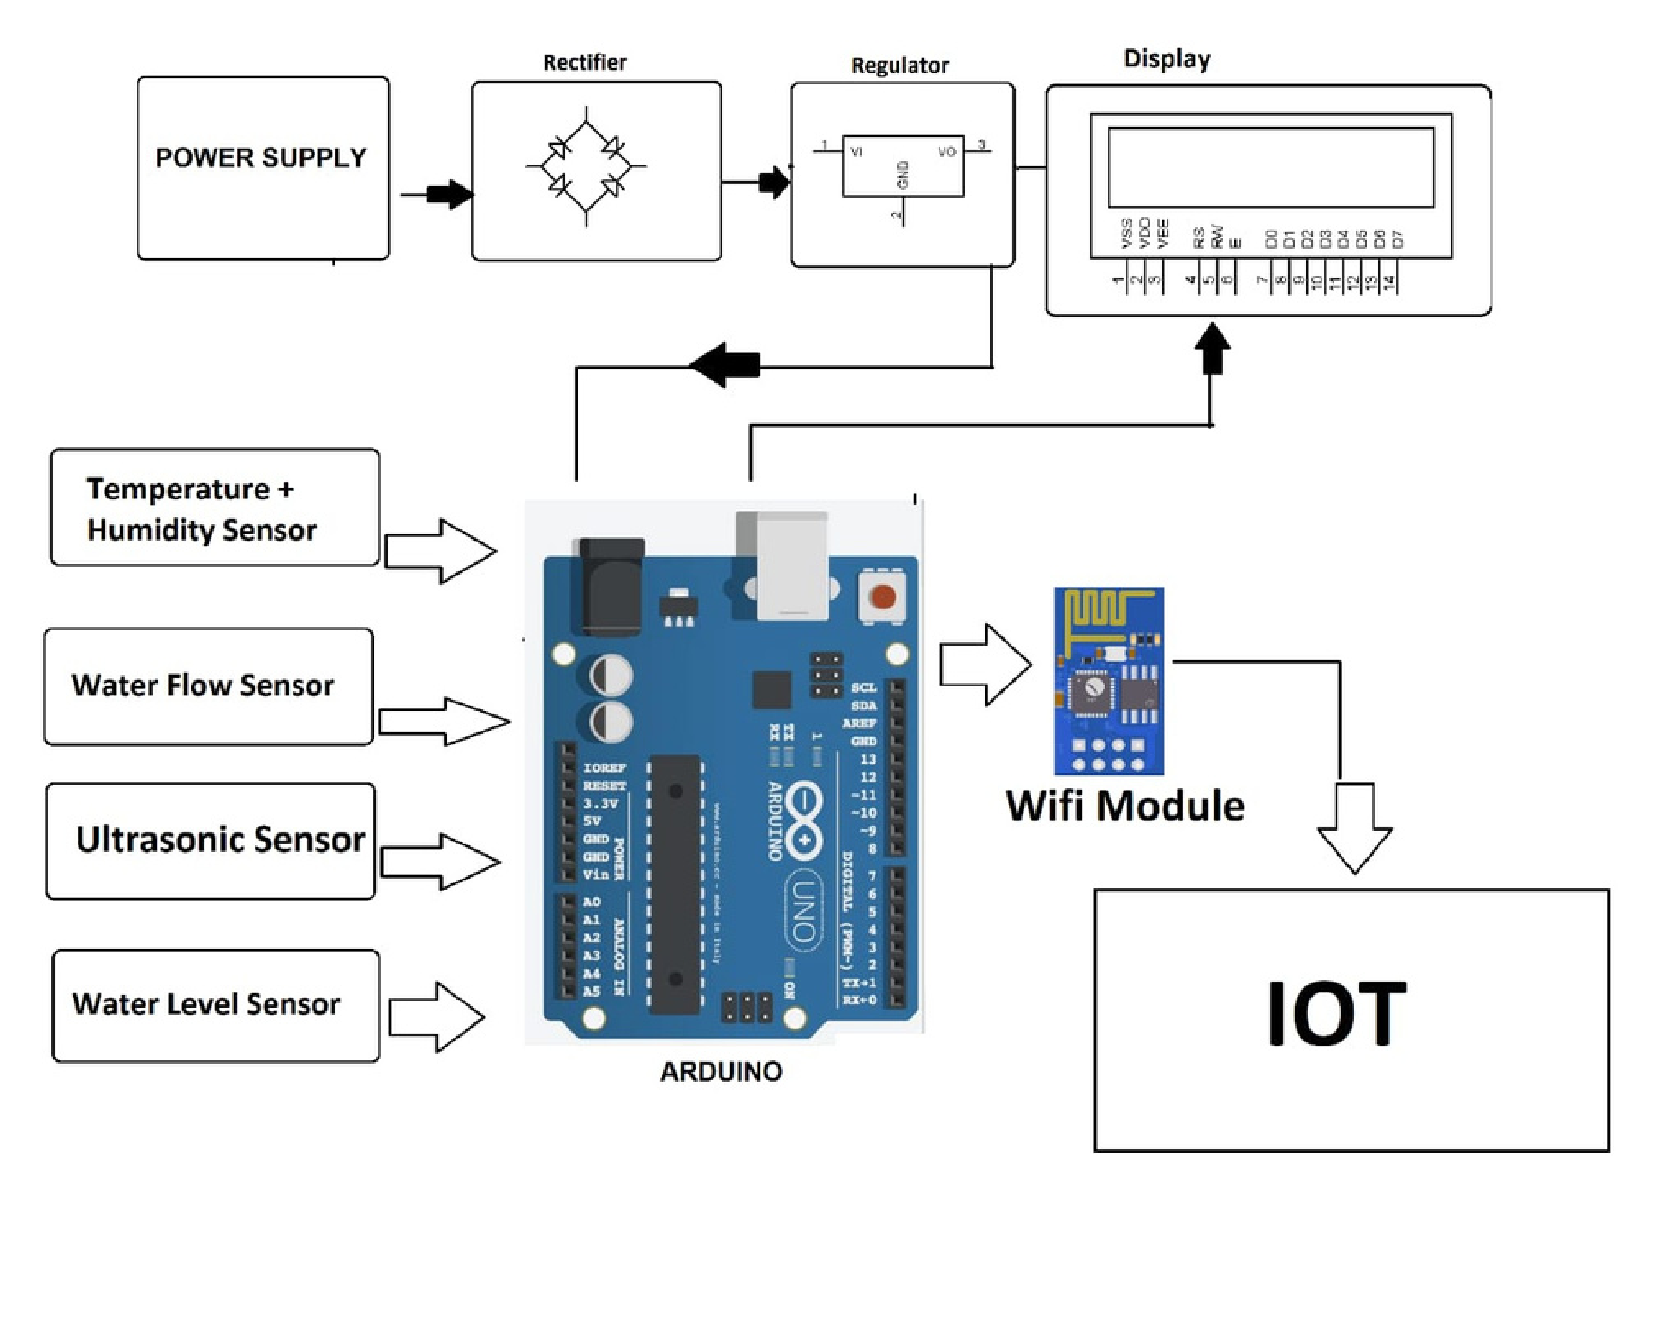

**STEPS INVOLVED**

1

. Sensor Deployment: Install a network of

sensors in flood-prone areas to measure

critical parameters such as water level,

rainfall, temperature, humidity, and

weather conditions. These sensors can be

placed in rivers, streams, drainage

systems, and other relevant locations.

2

.Alert Generation: Set up an alert system

to notify relevant authorities, emergency

responders, and the public when flood risk

levels exceed predefined thresholds. Alerts

can be sent via SMS, email, mobile apps, or

even sirens in high-risk areas.

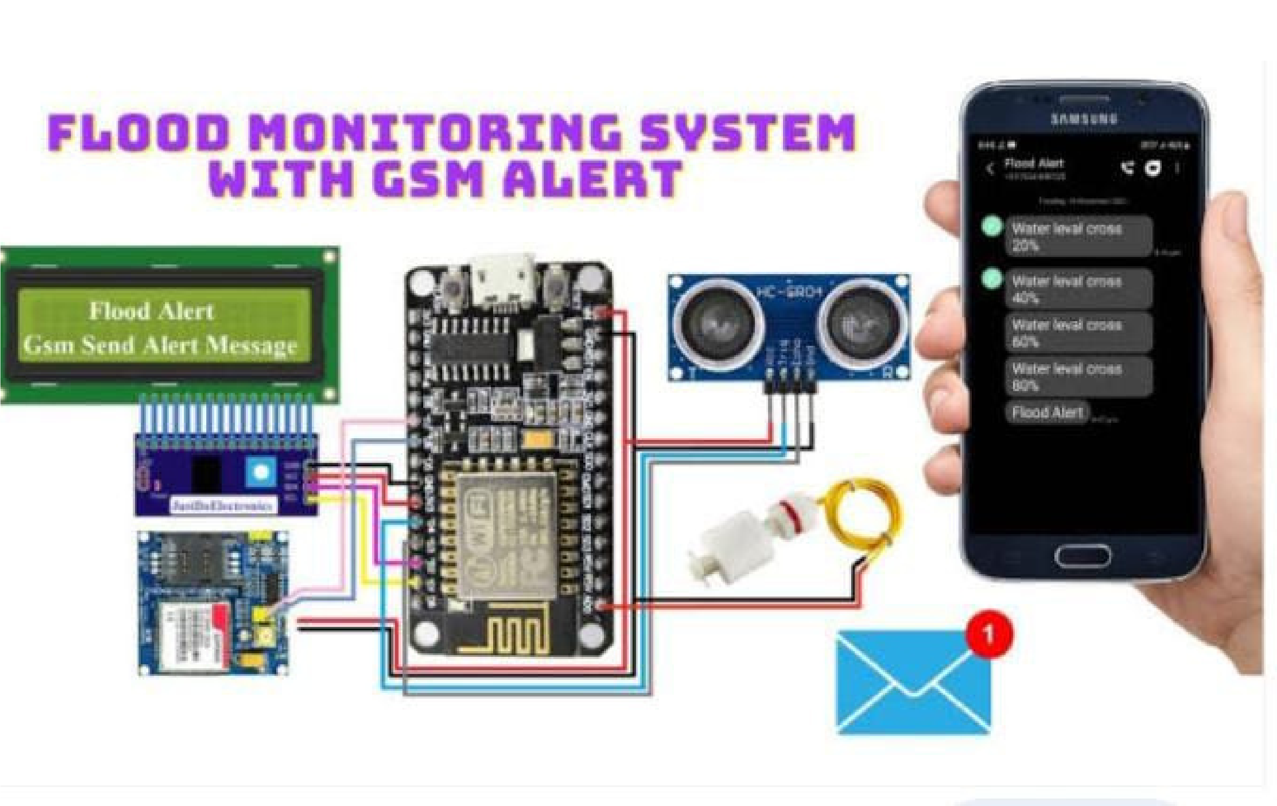

4

.Testing and Maintenance: Regularly test

the system to ensure sensors are

functioning correctly, data transmission is

reliable, and alerts are generated as

expected. Perform routine maintenance to

replace faulty equipment and update

software.

3

.Data Privacy and Security*: Implement

robust data security measures to protect

sensitive flood data from unauthorized

access or cyberattacks.

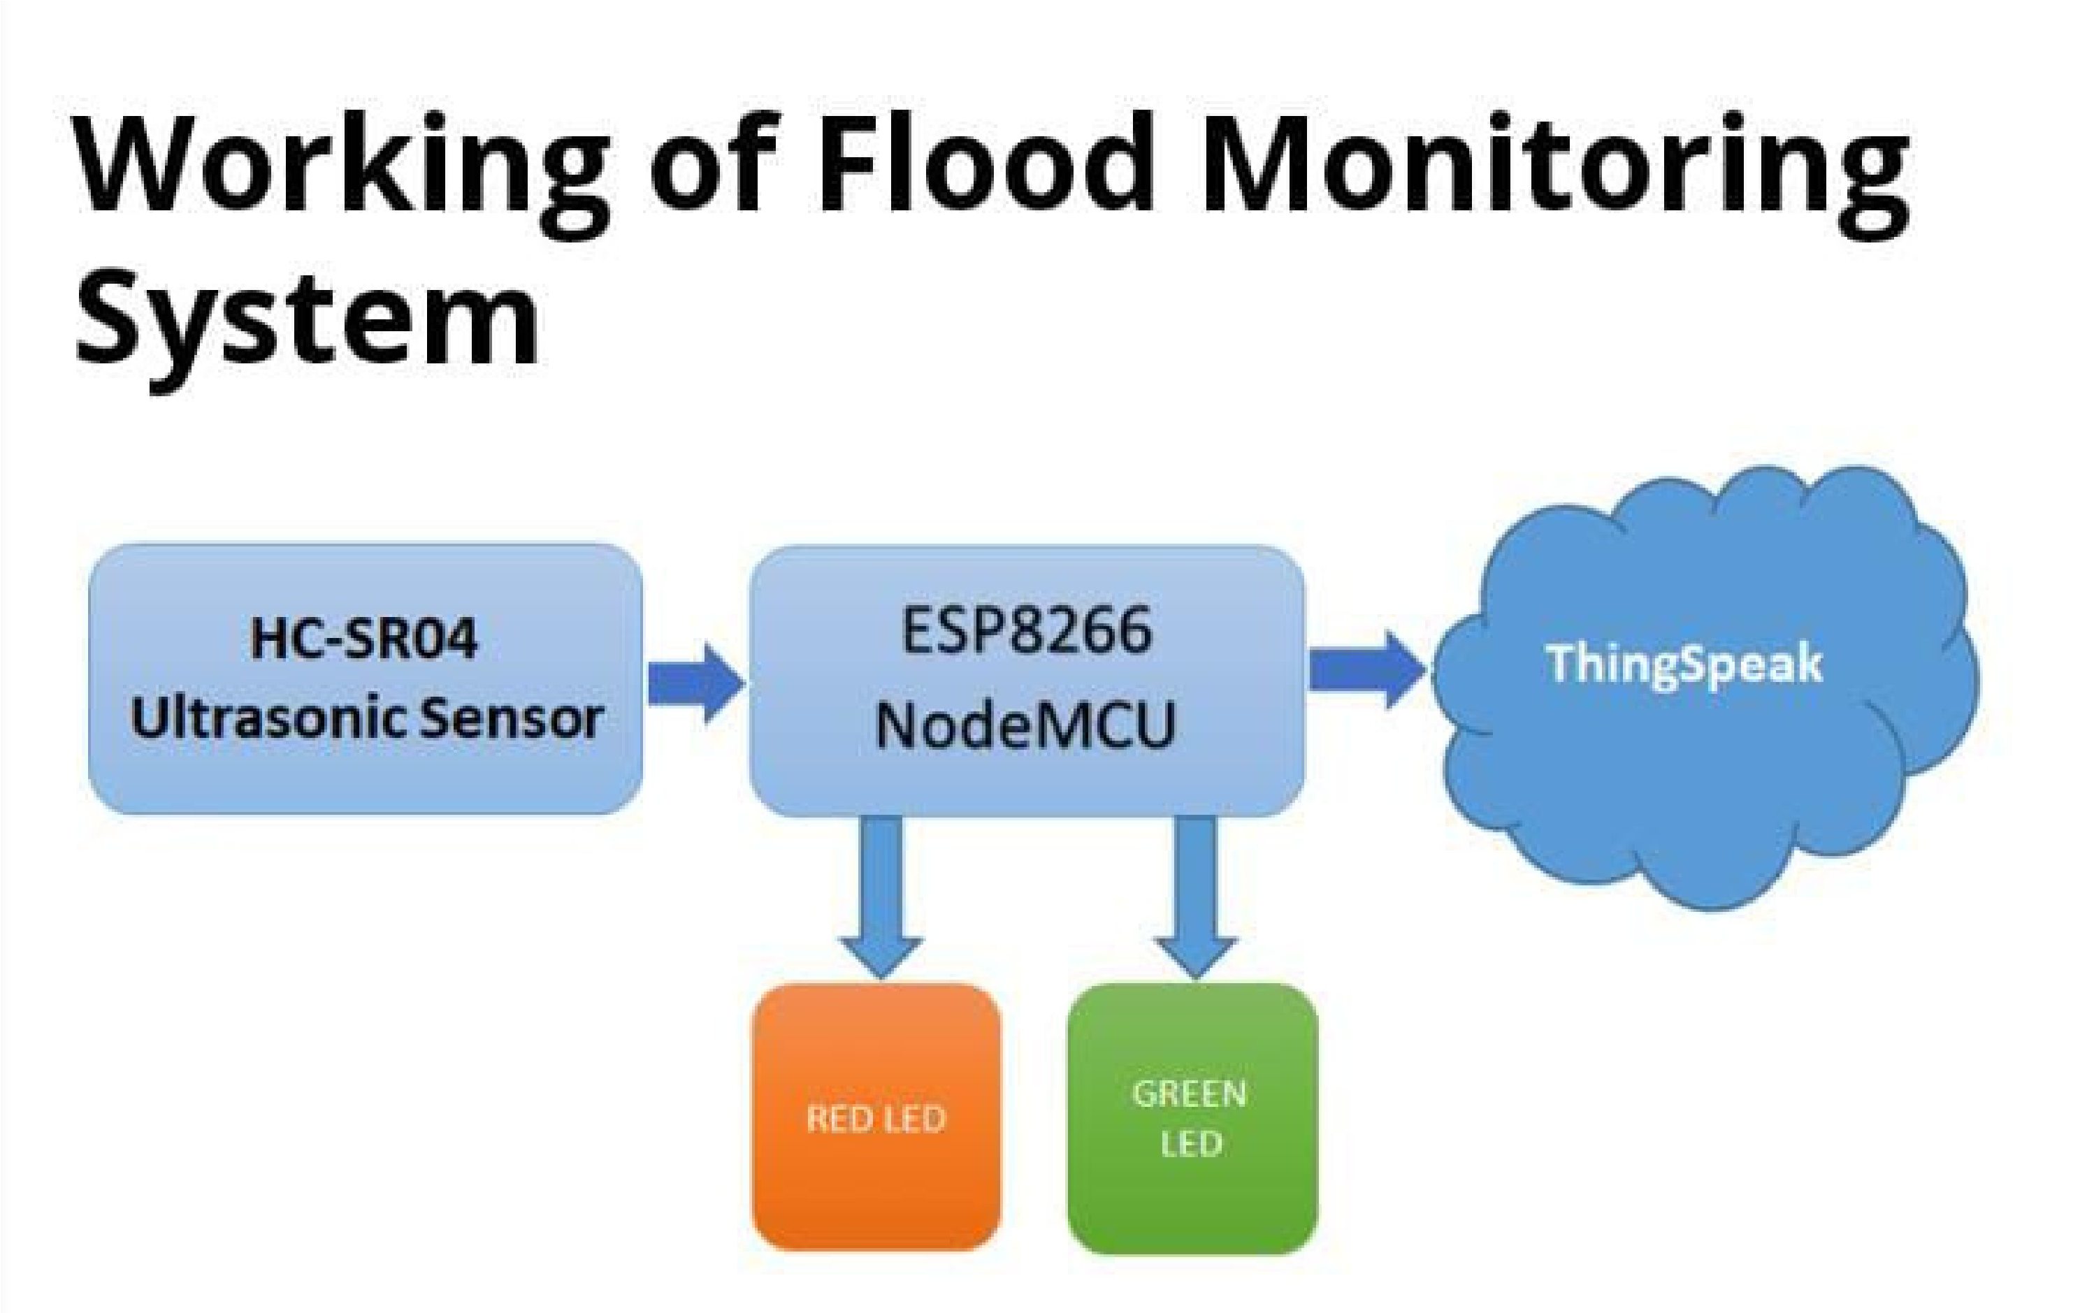**COMPONENTS REQUIRED**

1.ESP8266 NodeMCU

2.Ultrasonic Sensor

3.Power supply

4.LEDs (Red & Green)

5.Breadboard

6.Jumpers



**CONCLUSION**

A Flood Monitoring System in the realm of

Internet of Things (IoT) represents a

transformative solution designed to

address the increasing challenges posed

by floods, a natural disaster with

widespread and devastating

consequences.

we have gained the capability to create a

comprehensive and real-time monitoring

system that can continuously collect and

analyze data related to water levels,

weather conditions, and other relevant

parameters in flood-prone areas.